**Apple App Store vs Google Play Store**

Github: [krfennel/project2 (github.com)](https://github.com/krfennel/project2)

There has been a continuous debate when it comes to comparing the Apple App Store vs the Google Play Store for users, developers, and even investors. Our group would like to take a deeper dive into App data and analyze comparisons from an App Stores User’s point of view as well as determine what top attributes attract Users the most. Visual Aids showing comparisons and correlations of independent and combined data will be able to allow any User interacting with our Dashboard to review stats, charts and graphs to make their own analyzation rationale and a final determination on which App Store should reign supreme!

**Data Sets:**

Apple App Store: [Mobile App Store ( 7200 apps) | Kaggle](https://www.kaggle.com/ramamet4/app-store-apple-data-set-10K-apps)

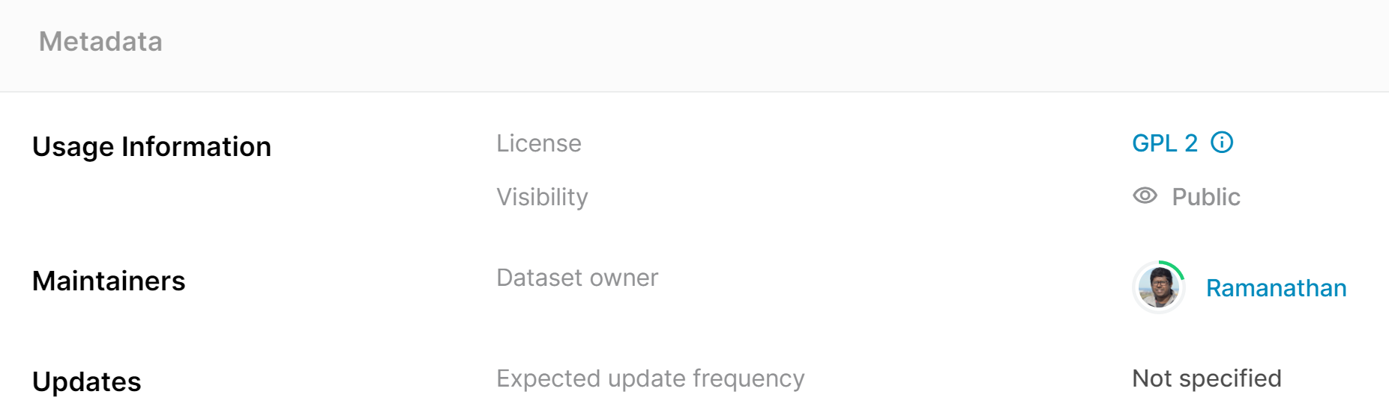

Google App Store: [Google Play Store Apps | Kaggle](https://www.kaggle.com/lava18/google-play-store-apps)

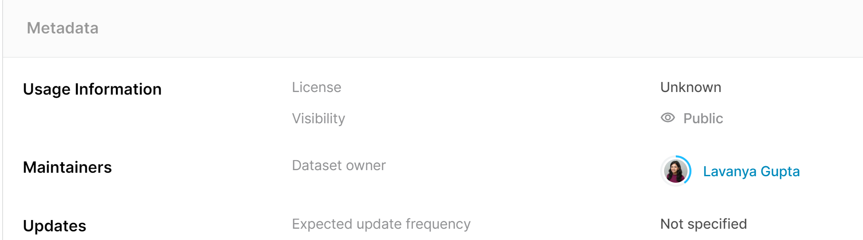

Dashboard Chart Examples:

|  |  |  |
| --- | --- | --- |
| Bar (Comparison) | Pie (Percentages) | Line/Scatter (Correlations) |